**TO-DO LIST MANAGER**

**A MINI PROJECT REPORT**

***Submitted by***

**Group/Team No: G29/T2**

**PARJOT SINGH G29/2310992490**

**PANKAJ KUMAR G29/2310992489**

***in partial fulfillment for the award of the degree of***

**BACHELEOR OF ENGINEERING**

***in***

COMPUTER SCIENCE & ENGINEERING



**CHITKARA UNIVERSITY**

**CHANDIGARH-PATIALA NATIONAL HIGHWAY**

**RAJPURA (PATIALA) PUNJAB-140401 (INDIA)**

DECEMBER 2023

###### TABLE OF CONTENTS

|  |  |  |
| --- | --- | --- |
| Sr.no | Section | PAGE NO. |
| 1. | Introduction | 1 |
| 2. | Problem Statement | 2 |
| 3. | Technical Details | 3 |
| 4. | Key features | 3 |
| 5. | Project Advantages | 4 |
| 6. | Bonus Features | 4 |
| 7. | Result | 5 |
| 8. | Conclusion with future scope | 8 |
| 9. | REFERENCE | 9 |

**INTRODUCTION**

**What is TO-DO list Platform?**

Definition:

A TO-DO list platform is a digital tool or application designed to help individuals or teams organize, manage, and track tasks and activities. These platforms come in various forms, ranging from simple list-making apps to comprehensive project management systems. They typically offer features such as creating task lists, setting priorities, assigning deadlines, sharing tasks with others, attaching files or notes, and sometimes integrating with calendars or other productivity tools. Popular examples include Todo List, Microsoft To Do, Trello, Asana, and Wunderlist (which has been absorbed into Microsoft To Do).

**Need:**

1. Task Organization
2. Time Management
3. Collaboration
4. Productivity Improvement
5. Task Tracking
6. Reminder of Task

**Motive of making to-do list:**

**Reason:**

Creating a website for a to-do list offers accessibility from any device with internet access, ensuring tasks are always at hand. It organizes tasks effectively, allowing for easy categorization, priority setting, and rearrangement. Collaboration becomes seamless as some sites enable sharing among teams. Reminders and notifications keep users on track, integrating with other tools for a comprehensive organizational system.

**Aim:**

Building a website for a to-do list streamlines task management by providing accessible, organized, and collaborative features. It ensures tasks are easily structured, categorized, and accessible from any device with internet connectivity. Collaboration becomes seamless, and integration with other tools allows for efficient task handling. Reminders and notifications keep users on schedule, while insights into productivity aid in optimizing efficiency. Ultimately, a to-do list website offers a versatile platform tailored to individual or team needs, enhancing productivity and task completion.

**PROBLEM STATEMENT**

**Individually Organized Tasks:**

We need to design our website that it should be organized the task according to the personal use. Or in other words “Design a to-do list solution that adapts to individual user preferences, allowing customizable categorization, tagging, and sorting options to streamline personal task management.”

**Notification and Reminder System:**

we need to Develop a to-do list application with a robust notification system that provides timely reminders, alerts for approaching deadlines, and customizable notifications to keep users informed and organized.

**Responsiveness:**

Making the website flexible to diverse devices/desktops, laptops, tablets, and mobile requires careful design and code to modify layouts and functionality.

**Browser-Adaptivity:**

There are some websites doesn’t support HTML5 language so. We need to develop a website that easily run on all types of browsers.

**Solution:**

**User Interface (UI) Design:**

- Conduct user research and usability testing to understand user preferences.

- Implement a clean, intuitive design with easy-to-understand controls for task management.

- Use responsive design principles to ensure compatibility across devices.

**Collaboration Features:**

- Introduce sharing functionalities allowing users to invite collaborators or assign tasks to

team member

- Implement real-time updates for shared lists or tasks to facilitate seamless collaboration.

**Task Organization and Prioritization:**

- Provide customizable sorting options (by date, priority, tags, etc.).

- Implement drag-and-drop functionality for easy task rearrangement.

- Offer different views (list, calendar, kanban) for varied user preferences.

**TECHNICAL DETAILS**

**Technical details**

* We have used HTML layout for building our base website and also use to upload pages.
* We use CSS so that our website looks wonderful and as beautiful as possible. Done lots of work on styling at all page.
* At later we will use JAVA-SCRIPT, so that whatsoever logic must be given we will include it in our website.
* We also needed a server or HOST for website, S o to achieve this we use PHP language.
* We have thoroughly tested the platform for functionality, security and usability.
* Have implemented automated testing wherever possible.
* We have the copyright to this platform under the regulations of 2023.
* We later add our premium membership, ads, or affiliate partnership.
* Images are used to make the website beautiful.

**Key Features:**

* We have used various images so that our website looks extremely original as a official/original website.
* We urge our users to please share their reviews on our platform, so that they can be promoted to distinct region of our country or abroad.
* We also added a printable to-do list, so that anyone can easily make a offline copy of their list
* This platform is very helpful for time management as this is the first platform in the world, which provide a printable to-do list
* We have also added sign up and registration page so that people can have access to our latest upload notification.
* Notification to users will be sent on regular basis.

**PROJECT ADVANTAGES**

**Accessibility:**

Users can access their tasks from anywhere with an internet connection, allowing for seamless task management on various devices

**Organization:**

It enables users to categorize tasks, set priorities, deadlines, and reminders, aiding in better organization and time management.

**Tracking Progress:**

Users can track their progress, mark tasks as completed, and visualize their accomplishments, fostering a sense of productivity and achievement.

**Time-Saving:**

A well-organized to-do list can save time by providing a clear overview of what needs to be done, reducing decision-making time and minimizing distractions.

**Security and Backup.**

Many to-do list websites offer data encryption, backups, and secure storage, ensuring

the safety of users' task information.

**Data Analysis:**

Some platforms offer analytics, providing insights into productivity patterns, helping users understand their habits and optimize their workflow.

**Bonus Features**

An alarm-enabled to-do list combines the efficiency of task management with timely reminders, revolutionizing how we approach our daily responsibilities. Seamlessly integrating alarms or notifications, this system ensures tasks are not merely listed but actively prompt attention at designated times. With this feature, users receive personalized alerts for crucial deadlines or important tasks, keeping them on track throughout the day. The synergy of a comprehensive to-do list and timely alarms fosters a proactive approach to productivity, empowering individuals to navigate their schedules with precision and efficiency.

**Result**

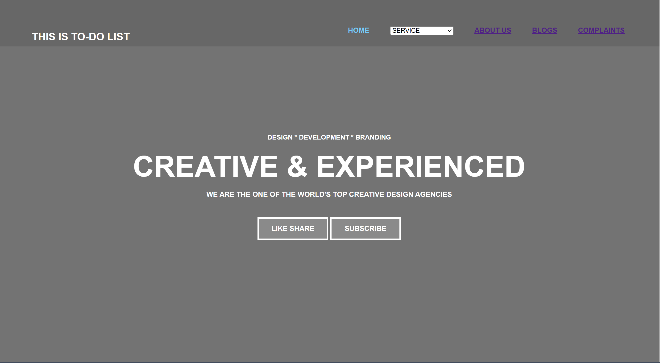

Figure 1: Home Page



Figure 2: ABOUT PAGE

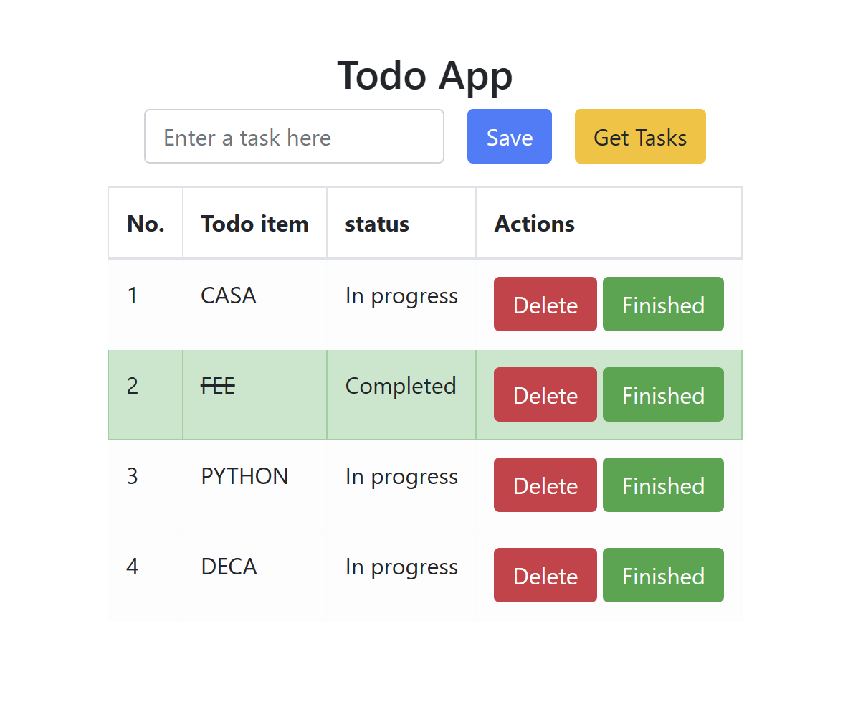

Figure 3:TO-DO LIST {Printable}

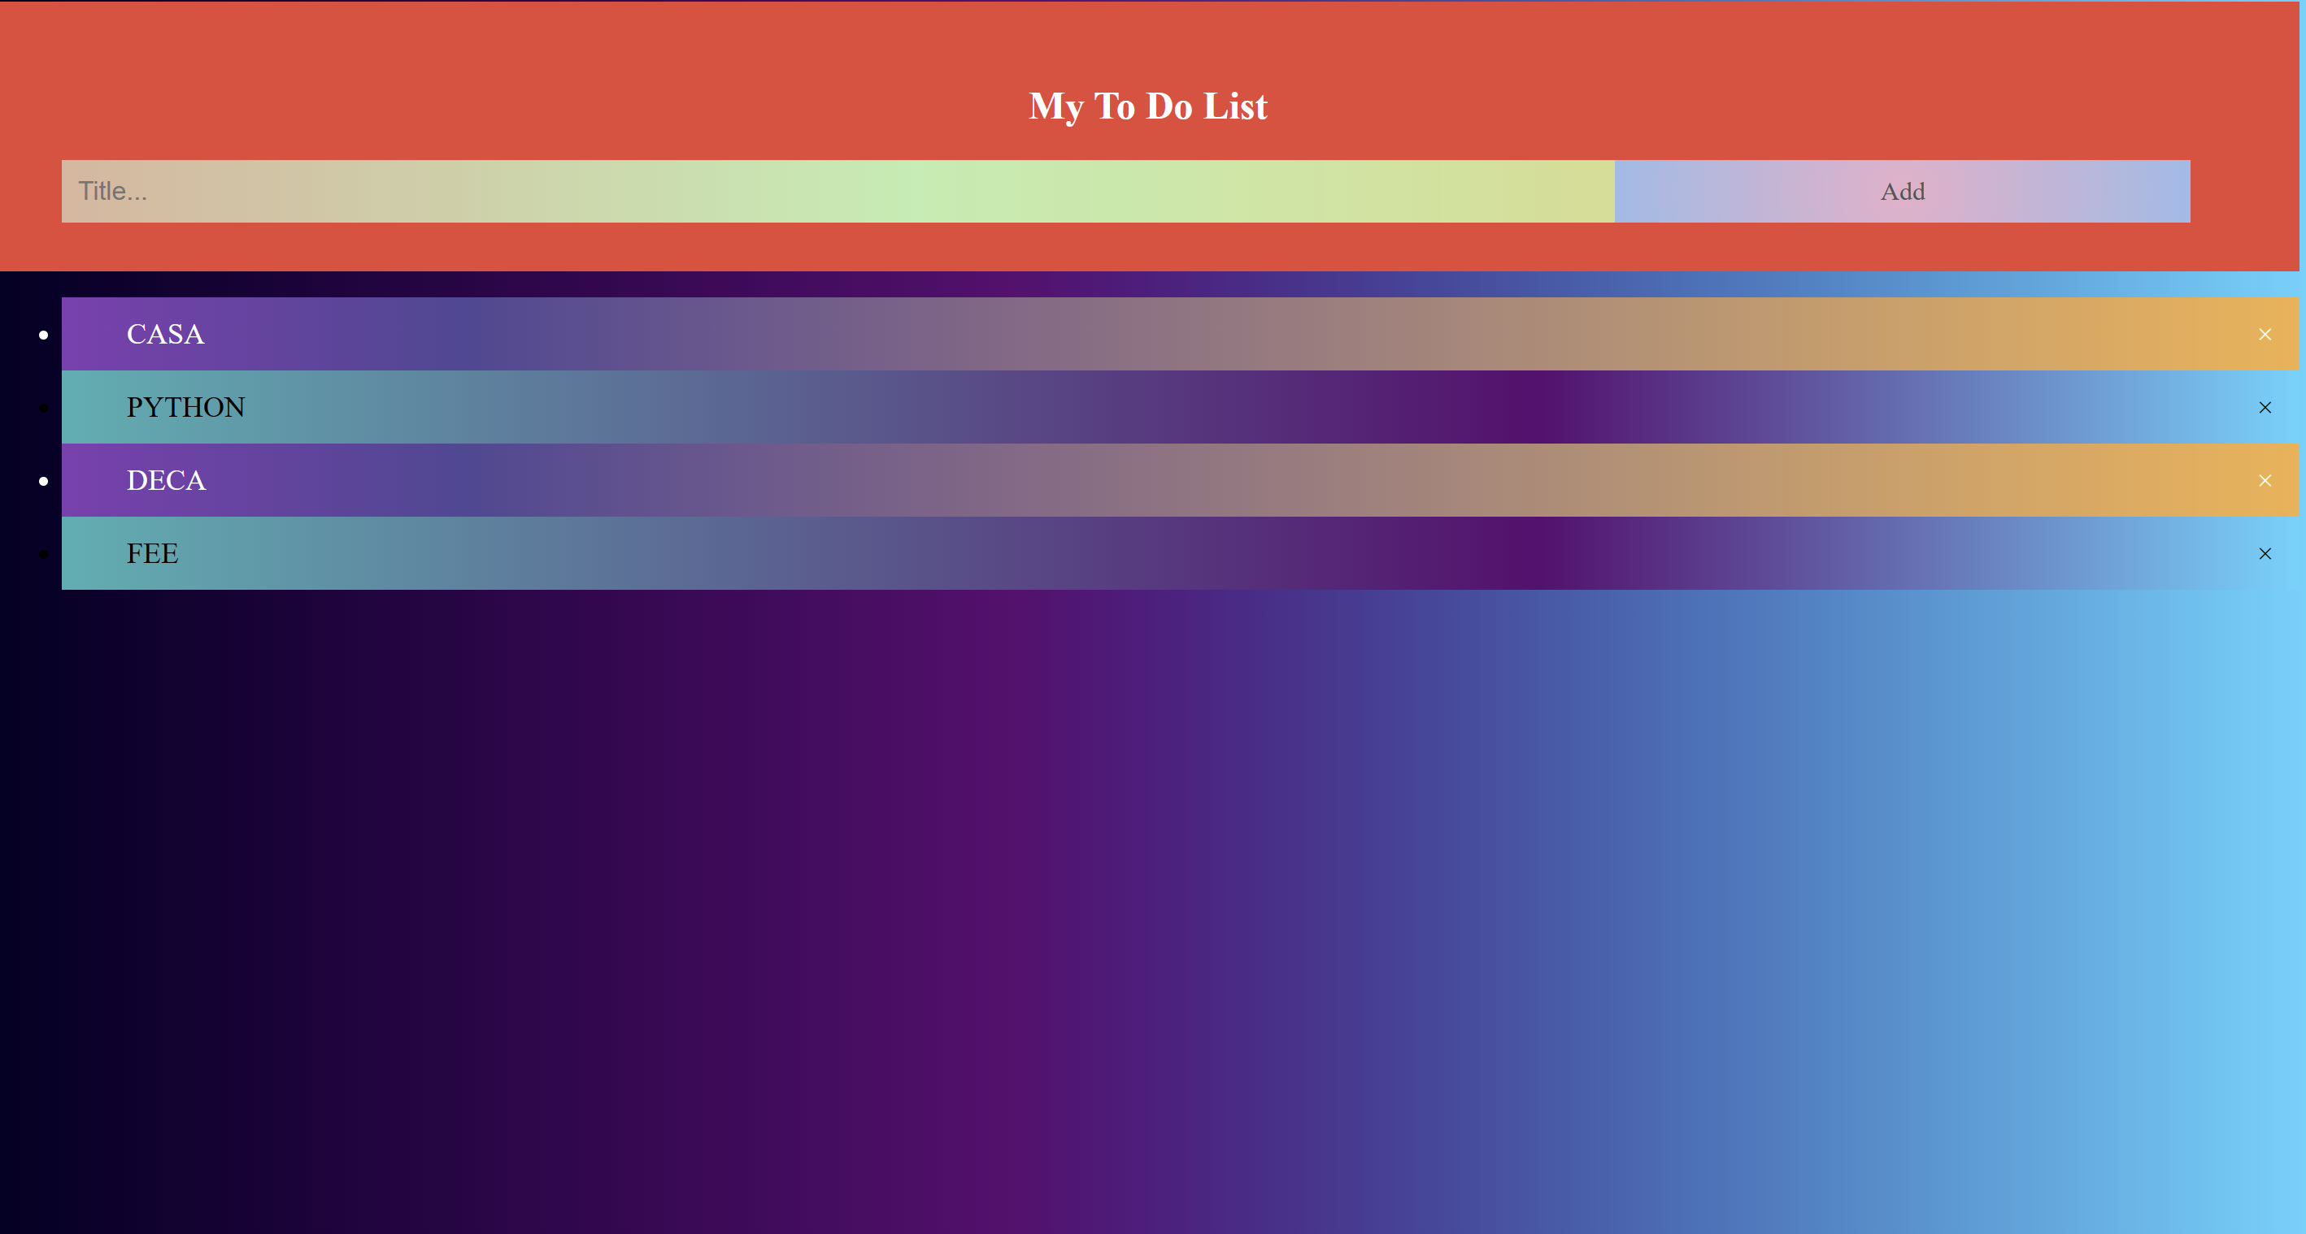

Figure 4: TO-DO LIST {odd\even priority levels}

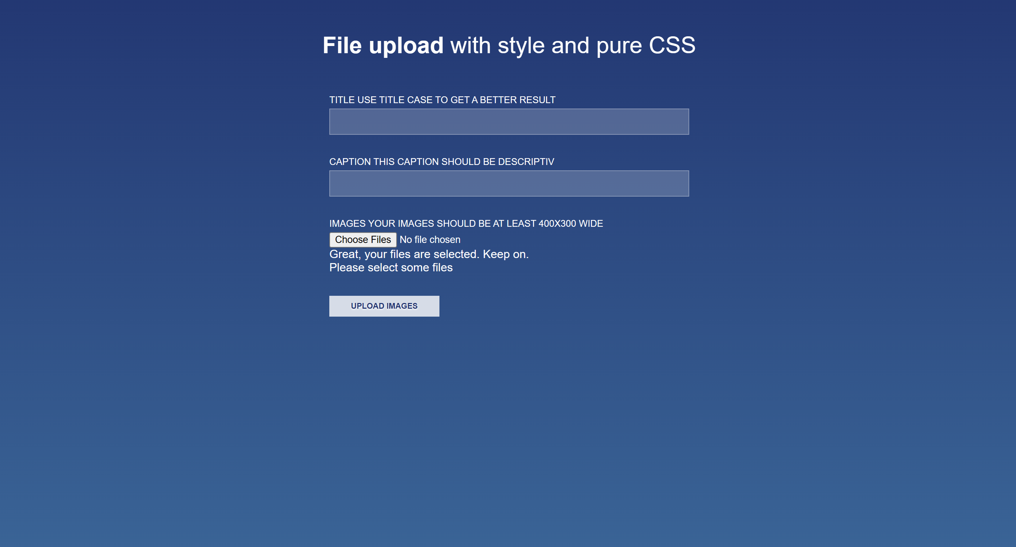

Figure 5: COMPLAINT



Figure 6: BLOG PAGE

**CONCLUSION**

**Efficiency and Organization:**

Todo list websites streamline task management, offering customizable interfaces to organize,

prioritize, and track tasks efficiently.

**Collaborative Potential:**

These platforms enable teamwork by allowing shared lists, task assignments, and collective progress

tracking, fostering collaboration among teams or groups.

**Timely Reminders:**

Reminders and notifications ensure timely action on tasks, reducing the likelihood of missing

deadlines and enhancing overall productivity.

**Insights and Analytics:**

Data insights and analytics tools provide valuable feedback, allowing users to refine their workflow

and optimize productivity based on patterns and trends.

**Adaptability and Accessibility:**

The to do list website's adaptability across devices and accessibility from anywhere with an internet

connection offer users a flexible means to manage tasks seamlessly.

**FUTURE SCOPE**

**Offline Usability:**

Offline Mode: Allows users to access and alter their to-do lists even while they are not connected to

the internet, with changes synchronizing once they reconnect.

**Enhancements to Security and Privacy:**

End-to-End Encryption: Ensures data security and privacy by utilizing strong encryption Technologies and Two-factor authentication adds another degree of protection to user accounts.

**Suggestions Powered by AI:**

Using AI algorithms to recommend activities, prioritize objects, or

anticipate deadlines based on user behavior.

**Gamification:**

Introducing gamified elements to increase user engagement and motivation.

**LIST OF REFERENCES**

[**Legacy Responsive Web Design Challenges | freeCodeCamp.org**](Legacy%20Responsive%20Web%20Design%20Challenges%20|%20freeCodeCamp.org)

[**CSS: Cascading Style Sheets | MDN (mozilla.org)**](CSS:%20Cascading%20Style%20Sheets%20|%20MDN%20(mozilla.org))

[**Sublime Text - Text Editing, Done Right**](Sublime%20Text%20-%20Text%20Editing,%20Done%20Right)

[**JavaScript Tutorial - Learn JavaScript (geeksforgeeks.org)**](JavaScript%20Tutorial%20-%20Learn%20JavaScript%20(geeksforgeeks.org))

[**Learn CSS (web.dev)**](Learn%20CSS%20(web.dev))

[**RGB Color Codes Chart 🎨 (rapidtables.com)**](RGB%20Color%20Codes%20Chart%20🎨%20(rapidtables.com))